Names: NTWALI Damien
SHIMO Fabrice
TUYISHIMIRE Yves
PREPARE PYTHON ENVIRONMENT
- 1.Download python from official websites
- Right click on python setup
- Select run as administrator
- Enable use admin privilege when installing python
- Enable add python.exe to path
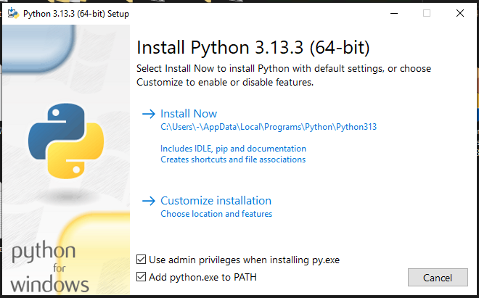
- Click install now
- 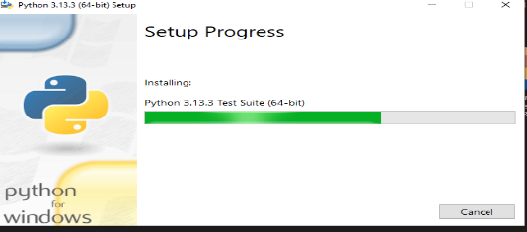
- Then installation complete
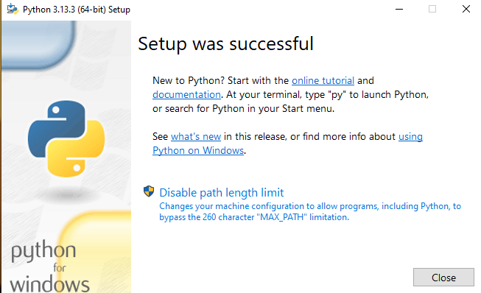

- Test python environment
